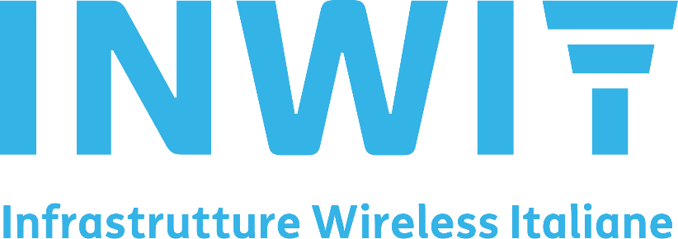

Quality, Environment and Occupational Health and Safety Policy

Approved by the General Manager

INWIT Infrastrutture Wireless Italiane S.p.A. (INWIT) is the largest operator in the wireless infrastructure sector in Italy and it builds and manages technological plants and civil structures (towers, pylons and masts) which house radio transmission equipment, mainly to serve telecommunications operators. It is leader in Italy with over 23,000 towers and around 49,000 hostings, with a set of assets equipped with the best-quality communication towers, widespread throughout the country. The widespread presence of INWIT towers means advanced services can also be offered in areas where fibre optic connectivity will arrive later, thereby expediting the digitisation of the country and the reduction of the digital divide.
The Company provides infrastructure capable of creating wireless networks, sensors, IoT and also offers a dedicated multi-operator coverage service through the use of DAS (Distributed Antenna System) and Small Cell systems in selected areas with high cultural and social value (airports, shopping centres, sports facilities, hospitals, etc..).
INWIT has defined a strategy focused on promoting and optimising its wealth of existing sites, improving operating profitability and attempting to intercept the demand for new sites, new infrastructure and services. At the same time, INWIT constantly focuses on maintaining and achieving increasingly higher levels of quality standards, to guarantee integrated hospitality services in line with the growing needs of the market. INWIT’s role of “neutral host” allows it to meet the demand of all the main market operators, both mobile and Fixed Wireless Access.
The Management of INWIT, aware of the importance of satisfying customers, integrating sustainability into corporate processes and, in particular, in order to ensure the highest levels of health and safety in the workplace for its employees, suppliers, customers and users, is committed to pursuing the following strategic objectives:
- create, maintain and improve a Quality, Environment and Occupational Health and Safety Management System compliant with the UNI EN ISO 9001:2015, 14001:2015 and 45001:2018 standards, in order to guarantee:
- customer satisfaction and the continuous improvement of the effectiveness and efficiency of processes;
- environmental and health and safety performance, starting from a standard level of legislative compliance, which is periodically checked;
- contribute to the creation and dissemination of an environmental and health and safety culture, involving the Management and all personnel;
- disclose the company’s main sustainability guidelines to all internal and external stakeholders;
- maintain open and constructive dialogue with the public authorities and all stakeholders;
- identify, qualify and involve the contracting companies to establish a relationship of mutual collaboration and trust in order to maximise the continuity and service levels provided to customers and reduce those companies’ impact on the environment in full compliance with Occupational Health and Safety regulations;
- fully comply and demand full compliance on the part of suppliers with current environmental and Occupational Health and Safety legislation;
- use economic resources to support investments in the expansion and continuous upgrading of its infrastructure network, services for customers and improvement from an environmental perspective, in terms of the circular economy, and Occupational Health and Safety in order to:
o reduce waste and the consumption of energy and non-renewable raw materials;
o prevent accidents and occupational diseases;
o prevent any form of pollution;
- research, assess and subsequently introduce technologies that are increasingly sustainable and high-performance in terms of processes as well as environmental and Occupational Health and Safety performance;
- identify and assess the direct and indirect environmental aspects, including the impact on biodiversity, and likewise the occupational health and safety risks of INWIT employees as well as those who work for INWIT according to the context (legislative, technological, operational, etc.) in force each time;
- periodically review the policies and management system to check and ensure their congruence, adequacy and appropriateness for the organisation and the effectiveness of their performance so that continuous improvement objectives can be reformulated.
INWIT undertakes, in particular, to:
➢ plan new sites and alter and maintain the existing ones taking into consideration the operations, continuity of the service and, last but not least, occupational health and safety of the workers (and third parties operating on behalf of INWIT) that access them;
➢ consolidate its assets and wealth of technical and professional knowledge of the highest level, creating a set of systems, processes and knowledge that can create value to serve the fast and efficient deployment of 5G by operators.
➢ maintain an adequate system to select, monitor and assess the performances of suppliers and contractors, in order to ensure the highest standards of effectiveness and efficiency of the service and the Occupational Health and Safety in the performance of their activities;
➢ steer evolution towards increasingly smart towers: digital assets, distributed and protected, that can make a solid contribution to the digital transformation of the country’s economic and social activities.
➢ identify new technologies that, in guaranteeing the best performance for customers, reduce the consumption of raw materials and the use of non-renewable energy sources;
➢ reduce its impact in relation to the production of greenhouse gas, through the production and purchase of energy from renewable sources and the choice, optimisation and reduction of the refrigerant gases used;
➢ manage waste by adopting strategies geared towards recycling and recovery, in order to increase the life cycle of materials and products;
➢ maintain a high level of auditing and surveillance/monitoring to identify and prevent any situations of non-compliance with plans or with its service levels, as well as with current legislation and the requirements of the Quality, Environment and Occupational Health and Safety Management System;
➢ control and reduce all emissions that are potentially polluting or that create a disturbance for local communities during the construction, operation and decommissioning of the technological infrastructures also with the collaboration of our customers;
➢ develop security plans containing measures and procedures necessary to prevent accidental or emergency situations, even environmental, and to contain the consequences;
➢ improve the impact on the landscape of its technological infrastructures;
➢ promote organisational well-being also through the implementation of evolved forms of work organisation (smart working), which enable work to be done more efficiently and with more flexibility, meeting people’s needs and, at the same time, reducing the environmental impacts.

